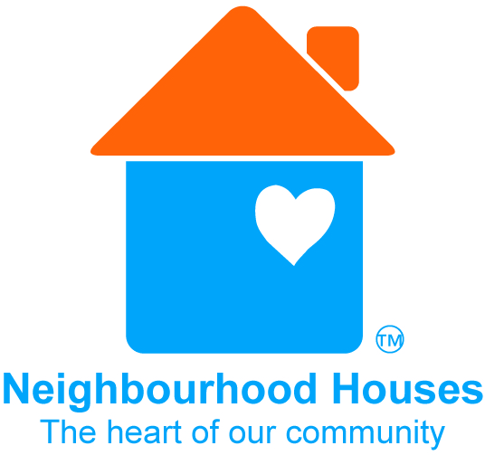

What if our house becomes a site linked to Coronavirus infection?
With COVID-19 still present in the Victorian community, there is a risk that your neighbourhood house could become a site linked to coronavirus infection.
It is important to take all the necessary precautions and manage community perception before and after a potential COVID-19 incident.

Mitigate risk and inspire confidence
Under COVID19 related restrictions, duty of care requires that your neighbourhood house implements policy and procedure in line with:
- DHHS Coronavirus Information – keep up to date on the current restriction levels and what they mean for managing your organisation: https://www.dhhs.vic.gov.au/coronavirus
- DHHS business sector advice. Note advice for cleaning and disinfecting tips for non-healthcare settings:
https://www.dhhs.vic.gov.au/business-sector-coronavirus-disease-covid-19
Responsible management will ensure that you are meeting your requirements – legally, you can only be held culpable if you are found to be negligent. Your Network Manager can provide you a checklist to work through. Each neighbourhood house is different so you must make appropriate decisions for your organisation.
To manage perception in the community, make sure to communicate all the precautionary measures you are taking. This will encourage people to feel safe and know how to behave in your organisation. It will also strengthen the ability of your organisation to ‘bounce back’ if your neighbourhood nouse is connected to a coronavirus outbreak.

Coronavirus response – act and engage
If there is a case of coronavirus connected to your organisation you will be contacted by health authorities. Be prepared for how your organisation will respond:
- Immediate closure of your facility – plan how you would communicate to staff and community members in the building in a way which avoids panic and encourages testing.
- Have a cleaning plan in place - who will do it, what equipment is required and how long it will take.
- Cooperate with health officials and contact tracing requests.
- Notify the community - prepare signage, website and social media posts, and a media release now so you have thoughtful materials ready to implement if the situation were to arise.
The longer term impact of coronavirus on your organisation will depend in how you respond to the situation.
Community trust is built on perception:
- Are you doing the right things?
- Can people see you are doing the right things?
- When incidents occur, do you respond appropriately, honestly and in good faith?

Further support
For further support on Coronavirus planning and prevention, contact your Network Managers on 0407 897 389, 0450 784 051 or networker@chn.net.au .

Acknowledgement: This document was originally created by the Central Highlands Association of Neighbourhood Houses.

