Completing the Service Agreement Compliance Certificate form in the Service Agreement Module
Contents
Introduction 1
About the Service Agreement Compliance Certification 2
Application of the SACC 2
Using this guide 3
Registration for My Agency 3
Completing your SACC 4
Navigate to the Service Agreement Module 4
Add FAR/ACFE BGS documentation to the SACC record 5
Open and complete the SACC form 6
View a submitted SACC 7
Update annual general meeting date 8
View SACC reports 8
More information 8

Introduction
From the 2015-16 financial year reporting period, and all reporting periods ending after 30 June 2016, organisations funded by the Department of Health and Human Services and/or the Department of Education and Training are required to complete a Service Agreement Compliance Certification (SACC).
For the 2016-17 financial year reporting period, and all reporting periods ending after 30 June 2017, organisations funded by Adult, Community and Further Education Board (ACFE) are required to complete a SACC form.
The SACC consists of a series of questions to be completed annually by the funded organisations which certifies compliance with Service Agreement requirements. The questions relate to:
- financial management
- risk management
- staff safety screening
- privacy
- ACFE Business and Governance Status (BGS) assessment (Note: Reference to ACFE BGS or VET funding contract under the Skills First Program in this document is applicable when the organisation is funded by ACFE)
The SACC will need to be completed in My Agency, the secure area of the Funded agency channel (FAC) website, where organisations update records and information regarding their funded services. Within My Agency, registered users of funded organisations will enter the Service Agreement Module (SAM) and be required to complete and submit their organisation's Service Agreement Compliance Certification (SACC).
This document provides detailed instructions that funded organisation follow as they complete and submit the SACC in SAM of the My Agency.

About the Service Agreement Compliance Certification
The SACC replaces existing requirements to complete a separate financial accountability requirement (FAR) organisation certification and risk attestation. These have been revised and consolidated into the SACC which also includes additional questions relating to safety screening and privacy.
The SACC comprises five sections:
- Financial management: that the organisation has used funding as outlined in their Service Agreement, is financially viable, has prepared its financial reports and any audit reports and maintains an asset register.
- Risk management: that risks are managed in accordance with the Australian/New Zealand Risk Management Standard
- Staff safety screening: that referee checks, police record checks and, if relevant, Working with Children Checks have been completed.
- Privacy: that the organisation’s practices and systems are compliant with the Privacy and Data Protection Act 2014 and the Health Records Act 2001 to protect personal and health information.
- ACFE Board Business and Governance Status (BGS): that the organisation has submitted an up-to-date ACFE BGS assessment or is eligible for an exemption to the BGS requirement under current ACFE guidelines.
By submitting a SACC form, organisations are making a commitment to the department that they have appropriate systems in place to comply with the relevant Service agreement requirements.
The SACC form reduces administrative burden for a large number of funded organisations by replacing two forms with one SACC form. In addition, disability service providers no longer need to complete the Disability Services Employment Safety Screening Compliance form which has been replaced by the SACC form. Most funded organisations will be required to complete the SACC in full.

Application of the SACC
Funded organisations will be required to complete the SACC from the 2015-16 financial year reporting period, and all reporting periods ending after 30 June 2016.
Depending on your organisation's reporting requirements, you may be required to complete two, three, four or all five sections of the SACC. The system will only display the sections you are required to complete. If you do not agree with what displays, contact your department adviser listed for your organisation in SAM.
If you answer 'No' or 'In Part' to any of the questions, you will be required to provide some brief details of the actions your organisation is taking to improve practices in response to the questions. You will also be contacted by your department adviser to discuss your answer/comments.
The SACC can be saved at any time, allowing for different areas of your organisation to individually complete different sections. It will be due 90 days after the end of your organisation's reporting period. However, if your organisation's annual general meeting (AGM) is after the due date you can now insert your organisation's AGM date in SAM and the SACC due date will automatically update to seven days after the AGM.
Once completed, the SACC should be submitted by an authorised person, such as the director, chairperson, chief executive officer, president, principal or treasurer.
If an organisation is unable to lodge its SACC online, they can complete a hard copy. However, this should only occur in exceptional circumstances as department staff will then have to complete the form online in SAM (Service Agreement Module).

Using this guide
This document includes information on how a funded organisation will complete the SACC in My Agency. The document provides sequential steps in screen shots to help the users follow.
It provides guidance to:
- navigate to the compliance tab to establish what action you need to take
- attach financial accountability requirements (FAR) and/or ACFE BGS documentation to the SACC record
  - complete, save and submit your organisation's SACC
  - advise/edit your organisation's annual general meeting date.
A red box outline in each screenshot of this guide will identify the area you need to select, action or note. In the example screenshot below, the organisation name is being identified for selection.
Figure 1: Example screenshot
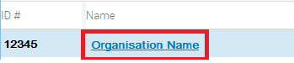
For additional information regarding the purpose of SACC, the roles of funded organisations and departmental staff and the scope of questions, please reference the Guidelines for the Service Agreement Compliance Certification (SACC) Form. The Guidelines are available from the Service Agreement Information Kit <http://go.vic.gov.au/GYN5wd>.
The video 'How to complete the SACC' is an additional resource to support funded organisations to complete the SACC. It is available in My Agency under Learning resources

Registration for My Agency
My Agency is the secure area of the Funded agency channel (FAC) website where registered users from funded organisations can access funding and payment information about their Service Agreement.
If you require access to FAC and are not a registered user, please refer to https://fac.dhhs.vic.gov.au/my-agency-non-dhhs-staff under My Agency for non-DHHS staff page of the FAC website < https://fac.dhhs.vic.gov.au/my-agency-non-dhhs-staff>.

Completing your SACC

Navigate to the Service Agreement Module
- Log into My Agency (via eBusiness). From the My Agency page, select: Service Agreement Module [External Link]
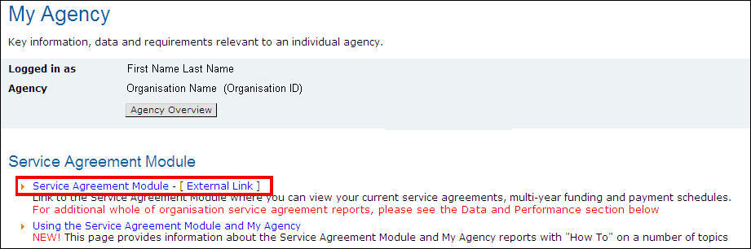
- A new window will open and the Service Agreement Module (SAM) will display. The Organisations tab at the top of the screen will default. Select the hyperlink (blue text) with the name of your organisation.
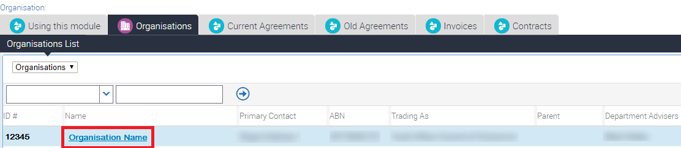

- The Organisations screen will open with a series of lower level tabs below the Organisation Details section. The Contacts tab will load by default. Select the Compliance tab.
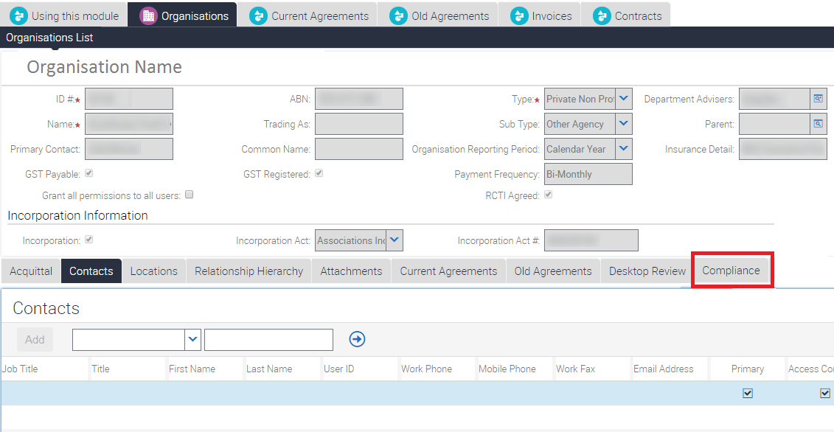

- Select the SACC record to be completed. The record will be highlighted. Ensure that the record you are working on has a status of Open.
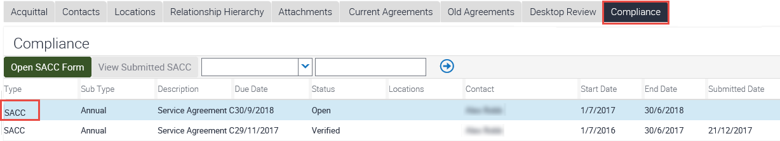
- Depending on your organisation's reporting requirements, you may or may not need to attach financial accountability requirements (FAR) documentation and/or ACFE BGS. If you are unsure, please refer to the Service Agreement Information Kit, Section 3.8.2 <http://go.vic.gov.au/OBzpFY>.
The first section of the SACC relates to financial management questions.
If you are not required to provide financial documentation and/or ACFE BGS, as part of your FAR or ACFE BGS requirement, go to step 15.
If you are required to provide financial documentation and/or ACFE BGS, go to step 7.
If you are not required to complete any financial management questions, go to step 15.

Add FAR/ACFE BGS documentation to the SACC record
- If you are required to provide financial documentation, as part of your financial accountability requirements (FAR), you can:
    - add a copy of your annual report containing financial statements
    - add a URL to a publicly accessible website, if your annual report is available online.
If your organisation doesn't produce an annual report, you can complete a financial indicators statement (FIS) or a cash indicators statement (CIS).
Templates can be downloaded from the Service Agreement Information Kit, Section 3.8.2 <http://go.vic.gov.au/OBzpFY>.
If you are required to provide ACFE BGS document, as part of ACFE guidelines, you can:
    - add a copy of your BGS
- On the Compliance tab, select the SACC record to be completed via selecting the word SACC on the far left of the record. The record will be highlighted. Scroll to the bottom of the screen and locate the Attachments section. Select New File.
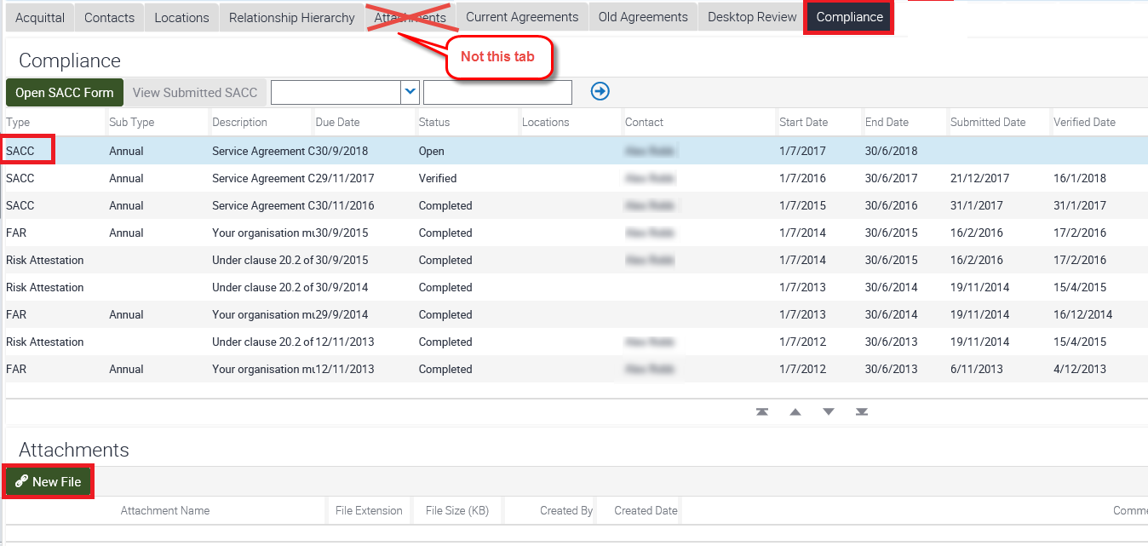
- The Choose File to Upload pop up box will display. Highlight the document you wish to attach (you can only upload one document at the time) and select the Open button.
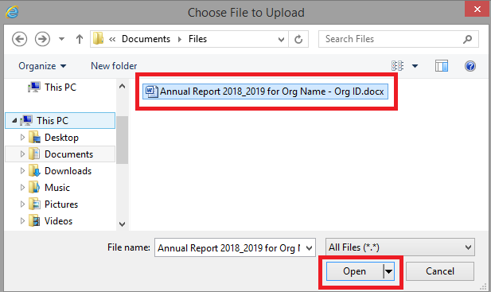
- This will take you back to the Compliance Attachments section and the document you added will display in the Attachment Name field. If required, you may also add comments (in the Comments field).
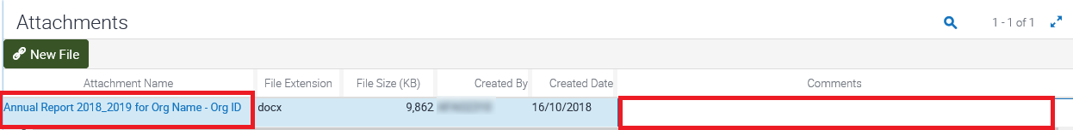

Open and complete the SACC form
- Ensure the SACC record to be completed is highlighted, by selecting the word SACC on the far left of the record. Select the Open SACC form button.
- Note: The Open SACC form will only become active after the reporting period end date. Until then, it will be inactive (greyed out).
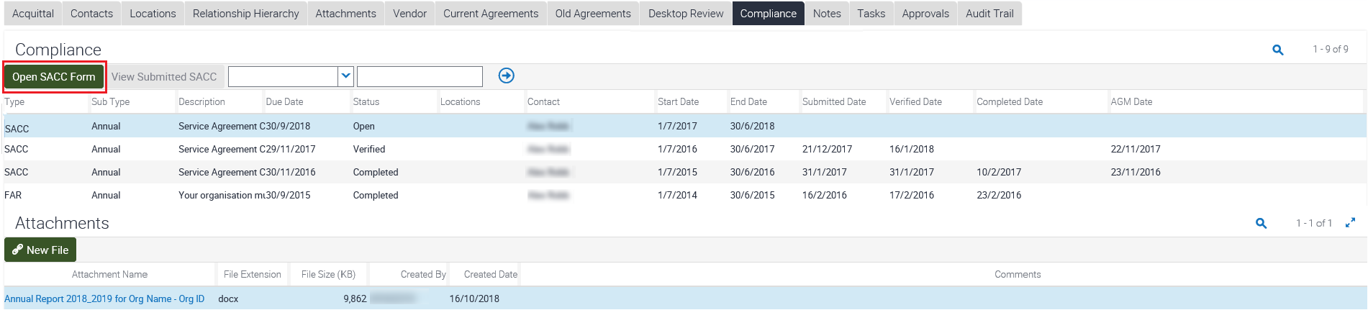
- The SACC form will display. There are five sections, but you will only see the sections your organisation is required to complete. Answer each question by selecting the most appropriate radio button.
You can save at any time and return to complete the SACC at a later stage, allowing for different areas of your organisation to individually complete different sections.
Note: The SACC will be due 90 days after the end of your organisation's reporting period. However, if your organisation's annual general meeting (AGM) is after the due date you can now insert your organisation's AGM date in SAM and the SACC due date will automatically update to seven days after the AGM (see step 19).
Once the SACC form has been completed, select the Submit button. The SACC should be submitted by an authorised person, such as the director, chairperson, chief executive officer, president, principal or treasurer.
Note: If you answer 'No' or 'In Part' to any of the questions, you will be required to provide some brief details of the actions your organisation is taking to improve practices in response to the questions. You will also be contacted by your department adviser to discuss.
- After submitting your SACC, the following message will display in the window: Thank you for completing your Service Agreement Compliance Certification form.
Both you and your organisation's Primary Contact will also receive a system generated email confirming that the SACC has been submitted.
Select the Close button to return to the Compliance tab.

View a submitted SACC
- You can view the information provided in any SACC with a status of Submitted, Verified or Completed. Choose the SACC record you wish to view, by selecting the word SACC on the far left of the record. The row will then be highlighted. Select the View Submitted SACC button. The SACC form in its entirety will display in a pop up box. It will show the original form with the answers selected and any comments displayed.
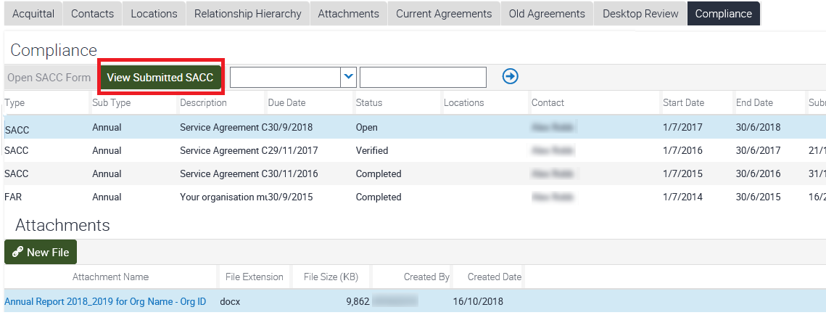

Update annual general meeting date
- If your organisation's AGM occurs after the SACC due date, you can update the AGM date and the due date will automatically change to seven days after the AGM.
Ensure the SACC record to be updated with the AGM date is selected by selecting the word SACC on the far left of the record. The record will be highlighted.
You can either enter the date (dd/mm/yyyy) in the AGM Date field, or select the calendar icon to the right of the field.
If you selected the calendar icon (to the right of the AGM Date field) a calendar pop up box will display.
Select the Month, Year, Day and the Save button in the Calendar pop up box. This will close the Calendar pop up box and insert the date you have selected in the AGM Date field.
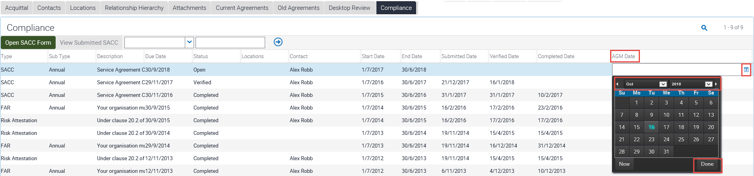
- Once the date is in the AGM Date field (via direct entry - dd/mm/yyyy - or via the calendar icon), the Due Date will automatically change to seven days after the AGM date.
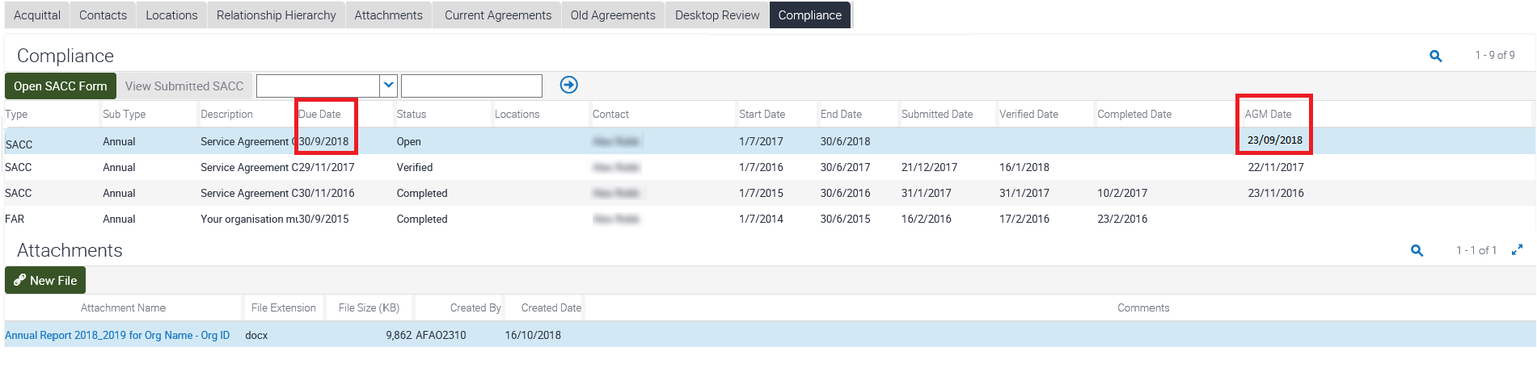

View SACC reports
A SACC report is available in My Agency under the compliance reports section. The report is in a printable format and displays the questions, answers and any comments provided to the SACC questions.

More information
For more information about the SACC questions, reporting and accountability, refer to the Service Agreement Information Kit Section 3.8.1 <http://go.vic.gov.au/GYN5wd>
You can also contact the department adviser listed for your organisation in SAM. Select the icon to the right of the department adviser for contact details.
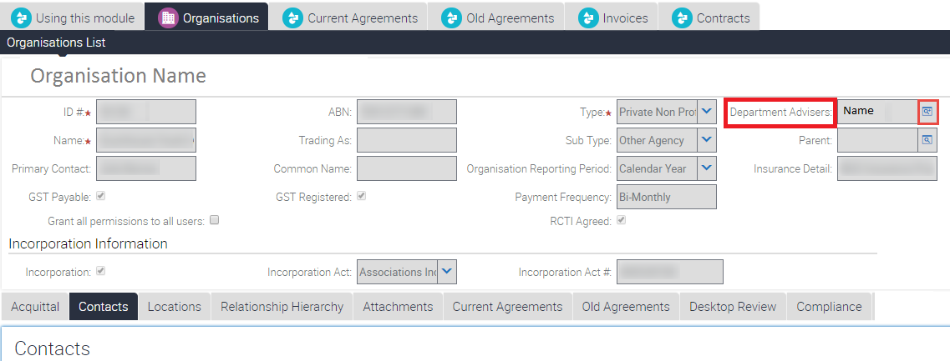

To receive this publication in an accessible format, email: the Funded Agency Channel <fac@dhhs.vic.gov.au>
Authorised and published by the Victorian Government, 1 Treasury Place, Melbourne.
© State of Victoria, Department of Health and Human Services, October 2018..
Available on the Funded Agency Channel <https://fac.dhhs.vic.gov.au/my-agency-non-dhhs-staff>

